Bahria University,

Karachi Campus



LAB EXPERIMENT NO.

___08__

LIST OF TASKS

|  |  |
| --- | --- |
| TASK NO | OBJECTIVE |
| 01 | Configure static route on the following network and show all necessary configuration steps for each router. |
| 02 | Configure static route on the following network and show all necessary configuration steps for each router. |
|  |  |
|  |  |

Submitted On

13-12-2023

(Date: DD/MM/YY)

**Task 01:** Configure static route on the following network and show all necessary configuration steps for each router.

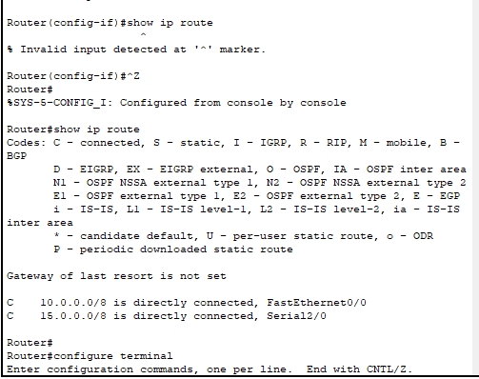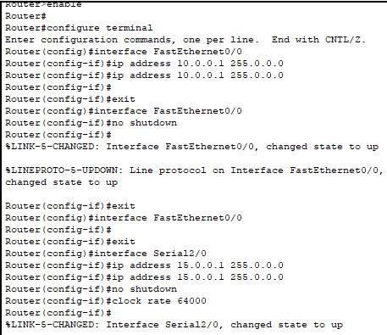**Solution:**

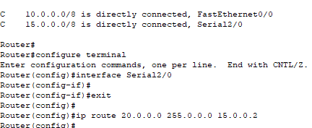

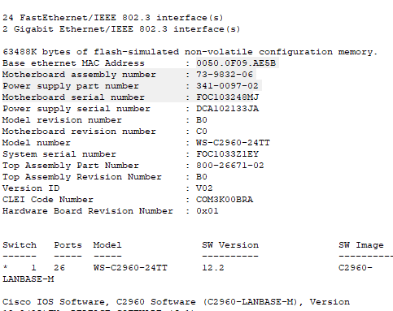

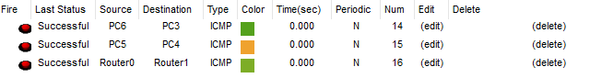

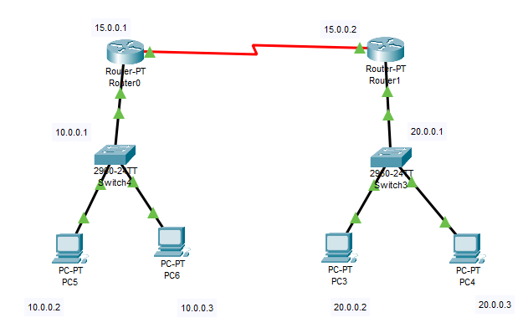

**Task 02:** Configure static route on the following network and show all necessary configuration steps for each router.

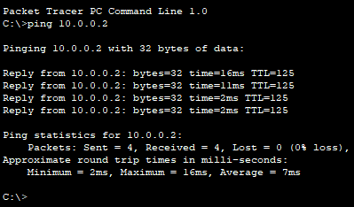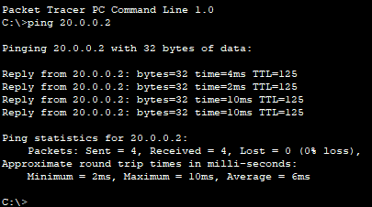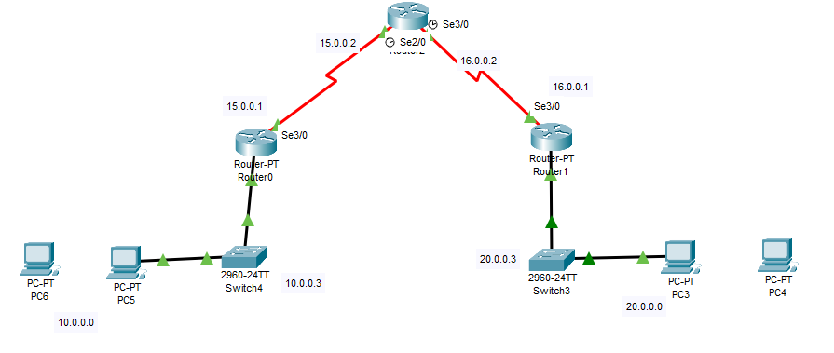**Solution:**